
REGION ONE SCHOOL DISTRICT

246 Warren Turnpike Road

Falls Village, CT 06031

Central Office (860) 824-0855
Pupil Services (860) 824-5639
Fax (860) 824-1271

December 4, 2019

Dear Parents, Faculty/Staff, and Administration:

On Monday, December 23, 2019, from 7:00 a.m. to 3:00 p.m., ceiling plaster which contains asbestos will be remediated from Housatonic Valley Regional High School, room 118. The district will be contracting with a licensed asbestos abatement contractor, which will be building a special containment area. The work will be monitored by a licensed environmental monitoring company. Per Connecticut regulations, no one under the age of eighteen years will be allowed in the building during that time. After 3:00 p.m., people under the age of eighteen years will be permitted in the building.

If you have any questions or concerns, please contact Jeff Lloyd, HVRHS Facilities Manager, at 860-824-5123, extension 146.

Sincerely,
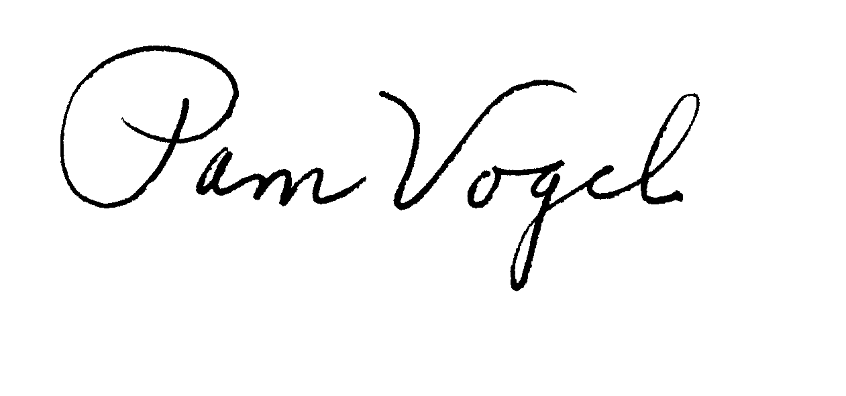
Dr. Pamela Vogel
Superintendent

Superintendent: Pamela Vogel Assistant Superintendent: Lisa Carter Business Manager: Samuel Herrick
Pvogel@region1schools.org lcarter@region1schools.org sherrick@region1schools.org

